Zhe cuisine（浙菜）
简介：
Zhejiang cuisine, alternatively known as Zhe cuisine, is one of the Eight Culinary Traditions of Chinese cuisine. It derives from the traditional ways of cooking in Zhejiang Province, which is located south of Shanghai and centred around Hangzhou, a historical Chinese capital. In general, Zhejiang cuisine is not greasy but has a fresh and soft flavour with a mellow fragrance.

Style：
Zhejiang cuisine consists of at least three styles, each originating from a major city in the province:

Hangzhou style: Characterised by rich variations and the use of bamboo shoots. It is served in restaurants such as the Dragon Well Manor.
Shaoxing style: Specialising in poultry and freshwater fish.
Ningbo style: Specialising in seafood, with emphasis on freshness and salty dishes.
Some sources also include the Wenzhou style as a separate subdivision due to its proximity to Fujian Province. Wenzhou style is characterised as the greatest source of seafood as well as poultry and livestock.

Dongpo pork (Chinese: 东坡肉; pinyin: dōngpōròu） is a Hangzhou dish which is made by pan-frying and then red cooking pork belly. The pork is cut thick, about 2 inches square, and should consist equally of fat and lean meat. The skin is left on. The mouthfeel is oily but not greasy and the dish is fragrant with wine. The dish is named after the famed Song Dynasty poet and gastronome Su Dongpo.

Legend has it that during Su Dongpo's life of poverty during his banishment to Hangzhou, he improved on the traditional process. He first braised the pork, added huangjiu (yellow wine) to make red-braised pork, then slowly stewed it on low heat. In their scholarly work Chinese Gastronomy, Lin Hsiang Ju and Lin Tsuifeng give the recipe “The Fragrance of Pork: Tungpo Pork,” and remark that the “square of fat is named after Su Tungpo, the poet, for unknown reasons. Perhaps it is just because he would have liked it.”

Dongpo Pork experienced three phases of popularity, from first appearance to mainstream appreciation. The history of the dish is said to parallel the experiences of Su Dongpo: from Xuzhou, a northern city of Jiangsu province, where Dongpo pork first appeared under the name of Huizeng pork; to Huangzhou, today Huanggang of Hubei province, where Su Dongpo finalized the method and recipe; and finally to Hangzhou, where Dongpo pork was officially named and became widely known across China.
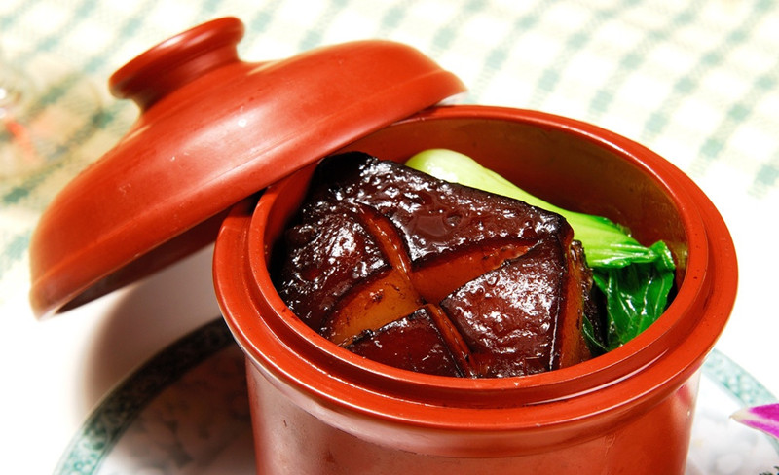

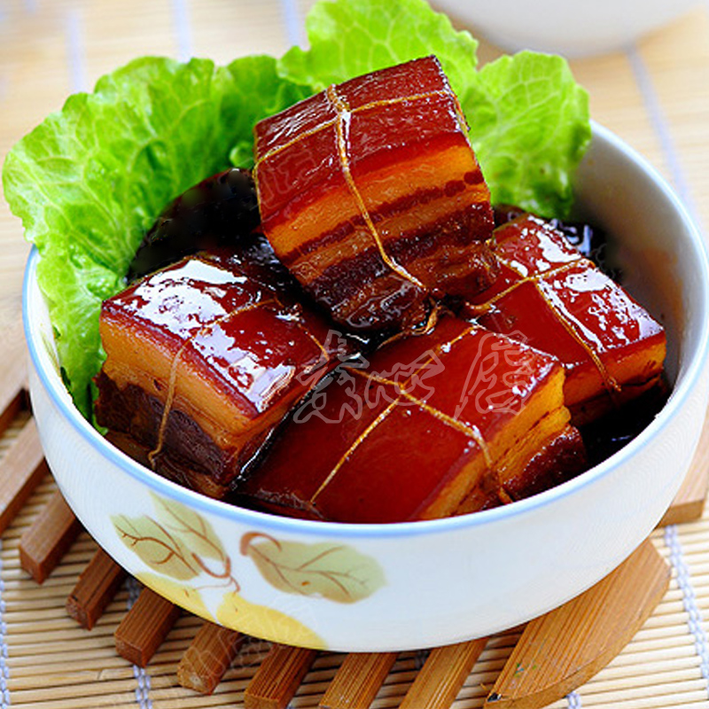

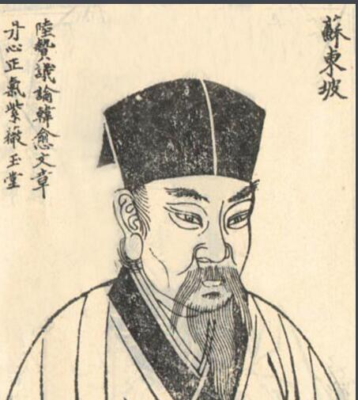

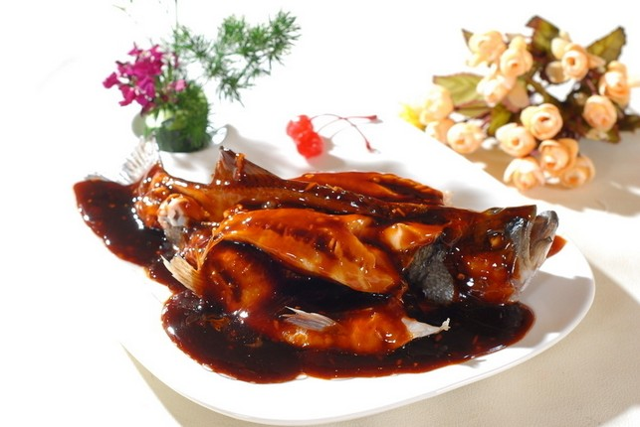

West Lake Fish in Vinegar Gravy (Chinese: 西湖醋鱼; pinyin: xīhúcùyú), also known as Song Sao Fish (Chinese: 宋嫂鱼; pinyin: sòngsǎoyú), is a traditional local specialty dish of Hangzhou in Zhejiang province. It first originated in Southern Song Dynasty. The material of West Lake Fish in Vinegar Gravy usually is the grass carp. After cooking, the chef will pour the smooth sugar and vinegar on the fish, which will cause the pectoral fin to stand up. In this way, the fish is tender and sweet with special crab flavor.

It is said that there was two brothers who made a living by fishing, Song and his brother. The local villain Zhao once visited the West Lake and saw a beauty, who was Song's wife. After realizing that the beauty was Song's wife, Zhao killed Song in order to marry the beauty. Because Zhao had cooperated with local government, Song's wife and the younger brother had no way to fight against Zhao. Song's wife asked the younger brother to escape in case of the revenge from Zhao. Song's wife cooked the fish with sugar and vinegar as farewell. The younger brother felt very strange to have fish with sugar and vinegar, which he had never tried before. Song's wife explained that the sweet flavor could support the younger brother to fight for a better life, and the sour flavor reminded him about the bad life the poor had. Song's younger brother moved a lot and worked hard after leaving Hangzhou. Several years later, Song's younger brother became an authority and put the villain into jail. When Song's younger brother wanted to find his sister-in-law, he couldn't because Song's wife hid away from the villain. One day when the younger brother had a lunch in a restaurant, he found that the fish was tasted just like the fish cooked by his sister-in-law. He asked who the chef was and found that the chef was his sister-in-law in surprise. Then the younger brother took Song's wife home and quit the job and made a living by fishing again. [6]

Later, a poet tried this dish and shocked a lot. The poet wrote a poetry on the wall of the restaurant with a strong feeling. The poetry was "裙屐联翩买醉来，绿阳影里上楼台；门前多少游湖艇，半自三潭印月回。何必归寻张翰鲈，鱼美风味说西湖；亏君有此调和手，识得当年宋嫂无。" The last sentence of this poetry is the record of the legend of "West Lake Fish in Vinegar Gravy" above.

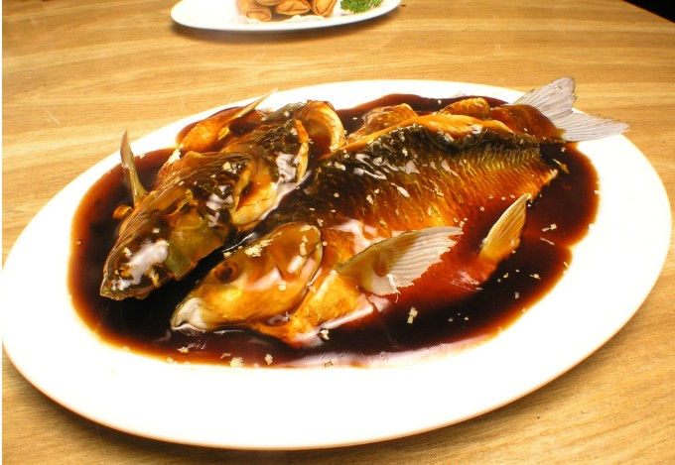

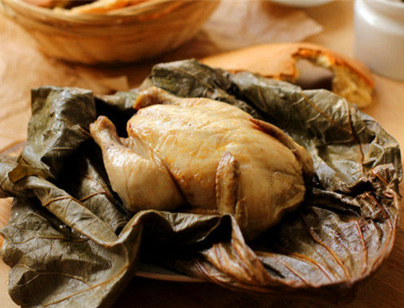

Beggar's Chicken （Chinese：叫花鸡 pinyin：jiàohuājī）is a Chinese dish of chicken that is stuffed, wrapped in clay, and slowly baked at low heat. It can take six hours to prepare a single serving.

As the dish is very popular in China, many regions claim it as traditionally theirs.Most experts agree that the dish originated in Hangzhou. The clay-wrapped, slow cooking method is thousand of years old in China.

Various legends surround the origins of Beggar's Chicken.In one, a beggar stole a chicken from a farm, but having no pot or utensils, improvised a cooking method. He wrapped the bird in lotus leaves and packed clay or mud around it, set it in a hole where he had lit a fire, and buried it to cook it. When he dug up the chicken and cracked open the clay, he found the meat to be tender and aromatic.In other versions, the beggar stole the chicken from the emperor and used the mud-hole method to avoid smoke which might attract the imperial guards;alternatively, the emperor stopped to dine with the beggar and so enjoyed the dish that he added it to the imperial menu, and the beggar prospered by selling it to locals.According to another legend, the dish had been a childhood favorite of Emperor Gaozu of Han, who had been born a peasant, and when he became emperor the recipe became an imperial specialty.

Today, the dish is often wrapped in lotus leaves and sometimes in pastry,though some recipes still call for a covering of non-toxic clay to retain moisture.
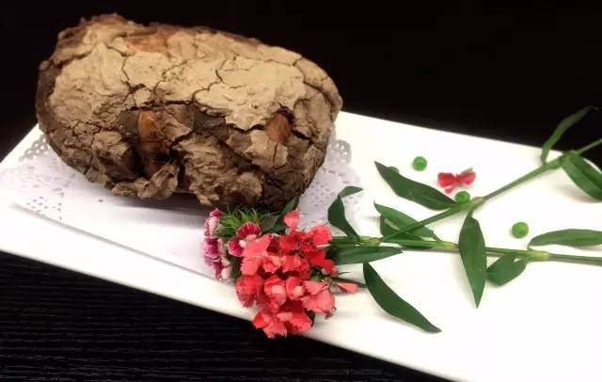

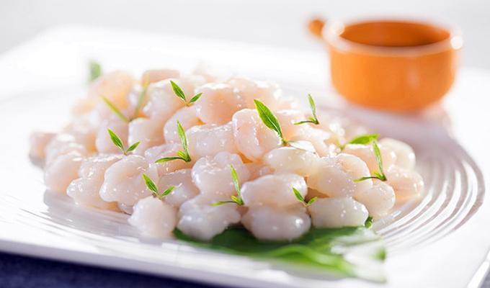

Longjing prawns, also known as shrimp stir-fried with Dragon Well tea, is a specialty of Hangzhou City, Zhejiang Province, produced using the meat of live river prawns coated with egg white and moistened starch, fried in lard at a medium-low temperature for 15 seconds, removed from the oil and drained when jade-white in colour, and then quickly stir-fried over extreme heat with boiling water infused with Longjing tea, tea leaves and Shaoxing wine. This dish consists primarily of white and green colours; the colours are elegant and the flavour is light and fragrant. According to legend it arose when the Qianlong Emperor of the Qing dynasty visited southern China. Hangzhou's famous Louwailou restaurant is a well-known producer of Longjing prawns.

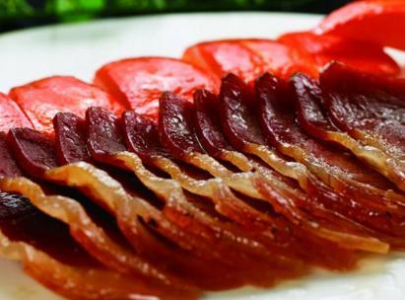

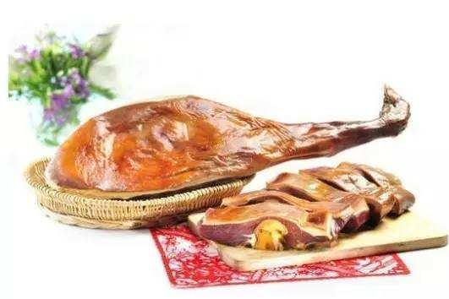

Jinhua ham is a type of dry-cured ham named after the city of Jinhua, where it is produced, in the Zhejiang province of eastern China. The ham is used in Chinese cuisines to flavour stewed and braised foods as well as for making the stocks and broths of many Chinese soups. The ham was awarded first prize in the 1915 Panama International Merchandise Exhibition. It is a well-known ham in China.

